SA2.1 WAP to perform the addition of two integers and display the result.

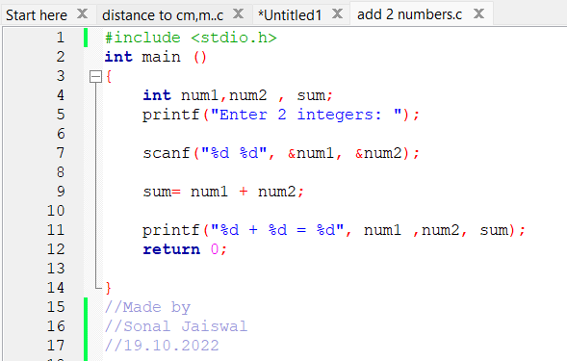Code:

Ouput:

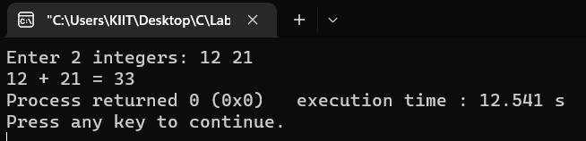

SA2.2 WAP to find centigrade for a given Fahrenheit temperature.

Code: 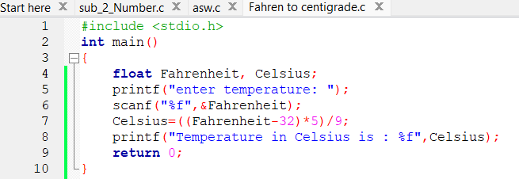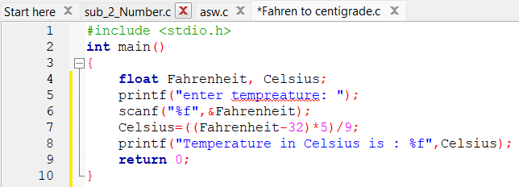

Output: 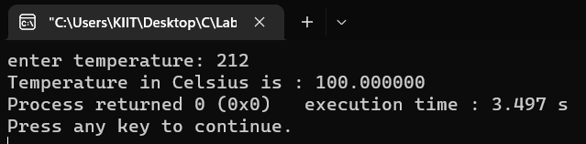

SA2.3 WAP to calculate area of a circle.

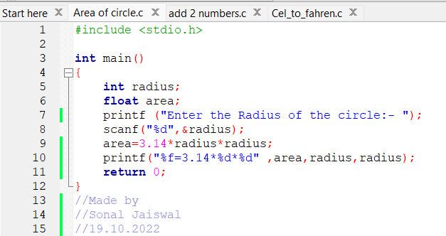Code:

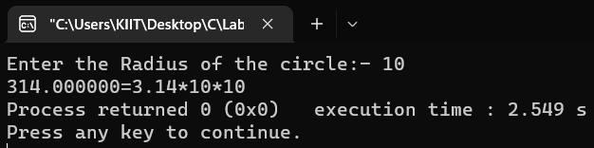Output:

SA2.4 WAP to calculate area of a triangle whose base and height is given.

Code: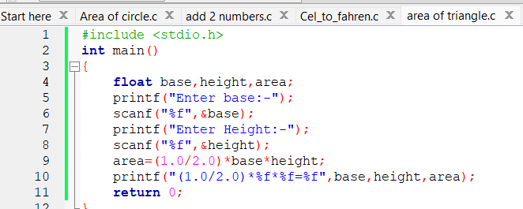

Output: 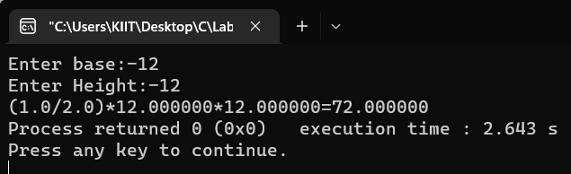

SA2.5 WAP to swap two integer numbers using third variable.

Code: 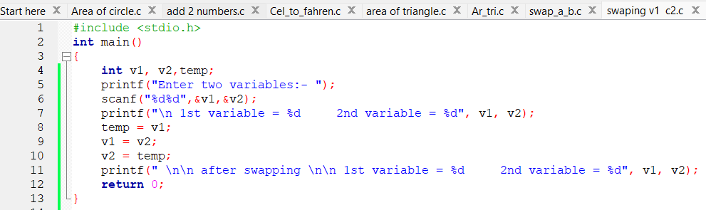

Output: 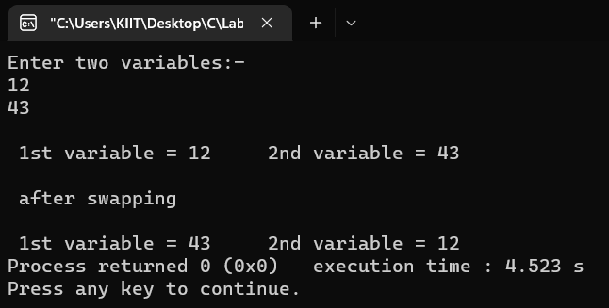

SA2.6 WAP to convert given paisa into its equivalent rupee and paisa as per the following format.

Example. 550 paisa = 5 Rupee and 50 paisa

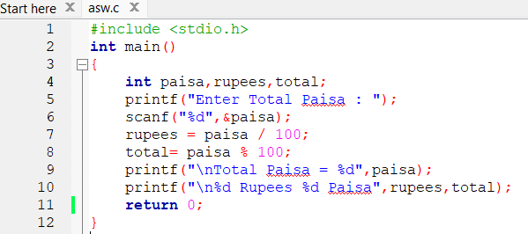Code:

Output: 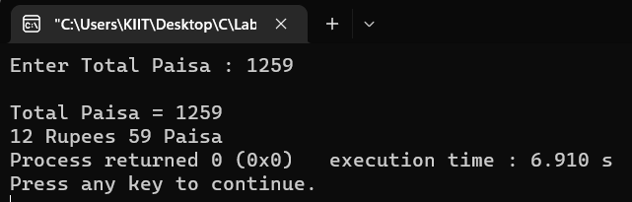

SA2.7 WAP to convert given second into its equivalent hour, minute and second as per the following format.

Example. 7560 second = 2 Hour, 27 Minute and 40 Second

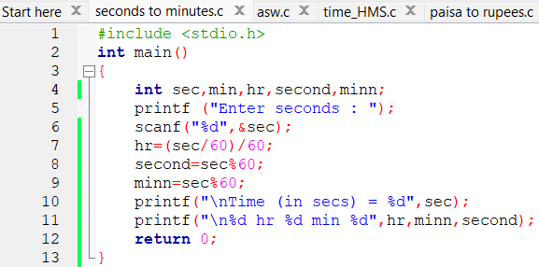Code:

Output: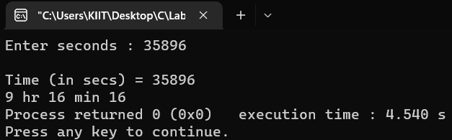

Lab. Assignments

LA2.1 WAP to subtract a number from another number and display the result.

Code: 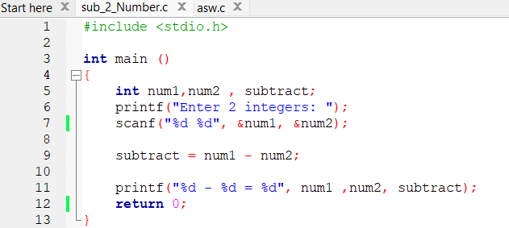

Output: 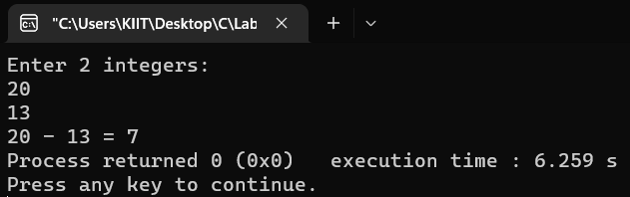

LA2.2 WAP to convert temperature from centigrade to Fahrenheit scale.

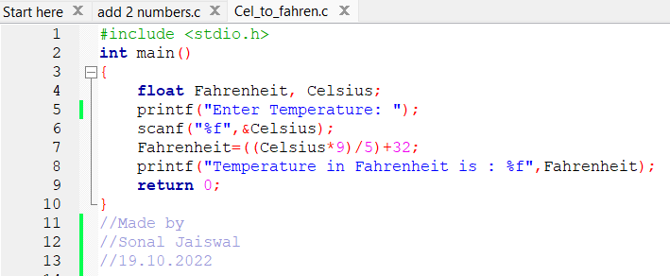Code:

Output: 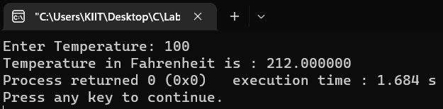

LA2.3 WAP to calculate perimeter of a circle.

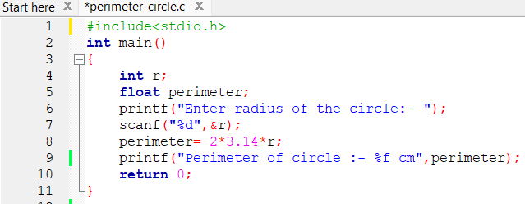Code:

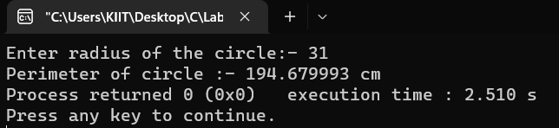Output:

LA2.4 WAP to calculate area of a triangle whose three sides are given.

Code:

Output:

LA2.5 WAP to swap two integer numbers without using third variable.

Code: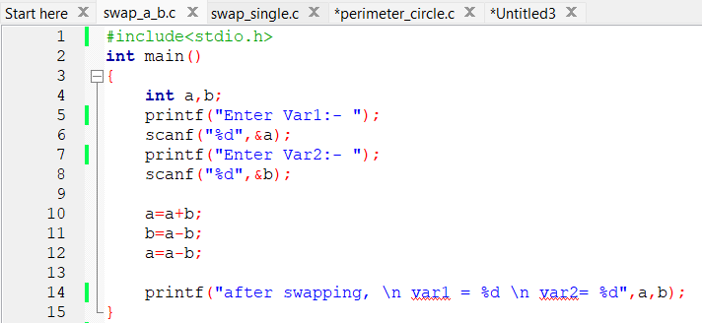

Output: 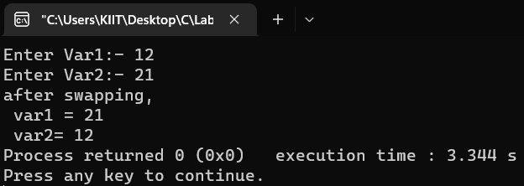

LA2.6 WAP to convert a quantity in meter entered through keyboard into its equivalent kilometer and meter as per the following format. Example. 2430 meter = 2 Km and 430 meter.

Code: 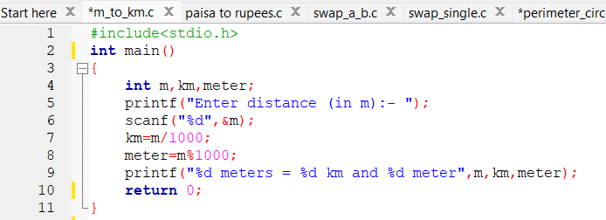

Output: 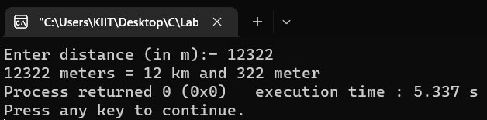

Home Assignments

HA2.1 WAP to find the average mark of 5 subjects of a student and find the percentage. Assume full mark of each subject is 100.

Code:

Output:

HA2.2 WAP swap the contents of two variables by using a single statement for swap in C.

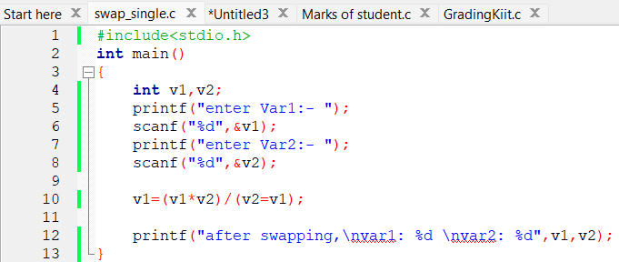Code:

Output: 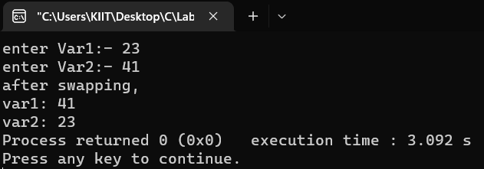

HA2.3 WAP to add two times in hour, minute & second format entered through the keyboard in the format hh:mm:ss

Code: 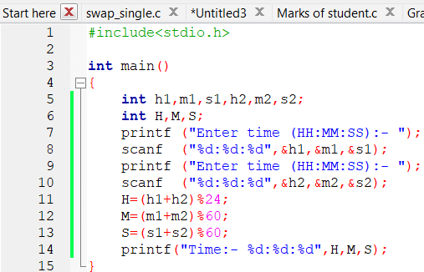

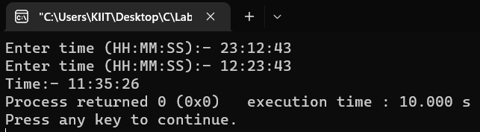Output: